G.W. LAKSHI IRUSHIKA MINOLI

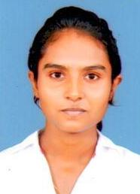

No. 128,

Pubudugama Niwasa,

Udumulla, Mulleriyawa.

Mobile:0774633643, 0756357326

**EDUCATION QUALIFICATIONS**

* G.C.E.Ordinary Level Examination in 2010

Buddhism A

Sinhala B

Health Science B

History B

Commerce C

Mathematics C

Science C

English S

* G.C.E. Advance Level Examination in 2013

Business Studies C

Economics S

Accounting S

**PROFESSIONAL QUALIFICATION**

* Following a ICT Course (NVQ Level 4) at NAITA
* Successfully Completed a Spoken English Course

**ACADEMIC QULIFICATION**

* BSc Business Administration University of Kelaniya.

**PERSONAL** **DETAILS**

* Name of full : G.W. Lakshi Irushika Minoli
* Date of birth : 25th February 1994
* Gender : Female
* Civil Status : Single
* Nationality : Sri Lankan
* School Attended : Yoshodara Balika Vidyalaya, Colombo 08

**REFAREES**

Mr. Dammika Nawarathne, Dr. W.H.U.D. Wijerathne.

Secretary to the deputy Minister, Medical officer , Ministry of Parliamentary Affairs Military Hospital

Palawatta , Narahenpita Battharamulla Colombo-05

Tel : 071-8079688 Mobile: 077-3371506

I hereby certify that the above information is correct and complete to the best of my knowledge & belief.

………………. …………………...

Date Signature